Project 3: Cloud Migration Technical Report
Matthew Santiago
University of Maryland Global Campus
CCS 640 Cloud Computing Implementations and Migrations
Charlie Shao
May 30, 2025

Executive Summary
In this report we will cover the plan to move BallotOnline servers into the cloud. The reason for this migration is to reduce costs and scalability by using cloud infrastructure. Through increasing data volumes in this age most on premise data centers cannot handle the vast amount of data needed to adapt to the changing internet and opportunities available without significant cost to the organization (TechTarget, 2023). The report will look at different AWS cloud migration services by examining the prerequisites then evaluating the tool. After this report will show proof of concepts for Data Migration of MySQL Database to AWS and Private Cloud (Hyper-V) Migration to AWS.

Plan Scope
The scope to guide BallotOnline through a cloud migration, which focuses on database and application migration. This will involve understanding the different migration strategies, evaluating different cloud migration tools, and performing a proof of concept for the migration. Our goal is to transition BallotOnline's IT infrastructure to the cloud in order to enhance operational efficiency and scalability.

Overview
Cloud migration requires the movement of applications and data from on-premises infrastructure into cloud infrastructure. AWS states that migration will “accelerate innovation and optimize costs by migrating and modernizing your applications and data” (Amazon Web Services, n.d.). BallotOnline needs to consider the best approach to data migration. The 2 main approaches to data migration are: “lift and shift” and “create new”. In the next sections we will discuss the tools, features, prerequisites and summarize the test deployments.

Cloud migration prerequisites
In order to have a successful migration, there are a few prerequisites that are needed. First and most important is that BallotOnline needs our executive team to understand and have clear goals for the migration. Second, a migration plan must be developed in order to have a step by step document on the transition and to inform executive leadership on the process. Third, will be the use of AWS migration hub which “provides a single place to discover your existing servers, plan migrations, and track the status of each application migration” (Amazon Web Services, 2025). Forth, ensure we discover all our on premise servers before migration and that the migration hub indicates it knows of all the servers. Once that is complete, receive a proceed from leadership then initiate transfer through the migration hub. Lastly, track the progress of the migration and then test deployments to ensure they are successful (Amazon Web Services, 2025).
Industry Leading Cloud Migration Approaches Overview
Due to best practices in conjunction with industry standards BallotOnline needs to consider the best approach to data migration. The 2 main approaches to data migration are: “lift and shift” and “create new”. According to AWS, Lift and shift is when you “Move an application to the cloud without making any changes” (Amazon Web Services, 2025). While create new is when you re-architect the application in order to take “full advantage of cloud-native features to improve agility, performance, and scalability” (Amazon Web Services, 2025). The data migration tools we will cover are: AWS Server Migration Service, AWS Database Migration Services, and the Azure Database Migration service. We will compare each tool, provide a usability evaluation of each tool and then summarize the results.

Cloud Migration Tool Sets
Feature Comparison
 | AWS Application Migration Service | AWS Database Migration Service | Azure Database Migration service
Function | Automatically converts applications and launch servers (Amazon Web Service, 2025)  Lift and Shift | Migrates databases through replication software (Amazon Web Services, 2025)  Create new | Migrates databases  (Microsoft, 2025)
Usability | AWS Console  (Amazon Web Service, 2025) | create a replication instance and connect schema with AWS Schema Conversion Tool (Amazon Web Services, 2025) | Portal, Powershell (Microsoft, 2025)
Deployment | Install the replication agent on source then configure EC2 launch settings (Amazon Web Service, 2025) | Needs source and target endpoints linked through replication instance (Amazon Web Services, 2025) | Azure Portal or PowerShell (Microsoft, 2025)
Support | AWS Support  CloudWatch and Migration Hub (Amazon Web Service, 2025) | AWS Support  CloudWatch and Migration Hub (Amazon Web Services, 2025) | Azure Support (Microsoft, 2025)

Evaluation Summary
The usability of AWS Application Migration Service, AWS Database Migration Service and Azure Database Migration service for BallotOnline is different and needs to be considered for the requirements that our migration needs. AWS Application Migration Service is console based which is easy for typical IT employees to manage. It automates the migration process and helps reduce manually syncing servers to EC2 (Amazon Web Service, 2025). The AWS Database Migration Service enables database migration to AWS database servers by replicating the data (Amazon Web Services, 2025). The set up for AWS Database Migration Service is more intensive than the Application Migration Service because you will need to set up endpoints and use the schema conversion tool to successfully enable the service. The Azure Database Migration Service uses the Azure portal and PowerShell for set up (Microsoft, 2025). This tool is similar and functions like AWS Database Migration Service. For users that are familiar with windows and azure this will be familiar for them but for others there will be a learning curve.
In summary, we reviewed the migration tools being considered for BallotOnline migration into the cloud. The tools we focused on were AWS Application Migration Service, AWS Database Migration Service and Azure Database Migration Service. The AWS Application Migration Service provides automated server migration through the use of the AWS command line. The AWS Database Migration Service enables database migration through data replication and encryption automatically after set up of endpoints. The Azure Database Migration Service functions similarly to other tools but requires users to learn Azure Portal or PowerShell for its operation. The tools are different in what they migrate, either applications or databases but depending on what cloud provider BallotOnline chooses the cloud specific tool for that provider is the best to use for migration.
AWS Database Migration Service
Overview
The AWS Server Migration Service was discontinued on March 31, 2022 and was replaced by AWS Application Migration Service as the “primary migration service for lift-and-shift migrations” (Amazon Web Services, 2025). AWS Application Migration Service works as an automated “lift-and-shift (rehost) solution that simplifies, expedites, and reduces the cost of migrating applications to AWS” (Amazon Web Service, 2025). This service enable quick migration into the cloud by automatically converting and launching the servers on AWS (Amazon Web Service, 2025). This service also allows tracking of the migration and launch progress inside the migration hub, additionally allows for the organization to move servers easily into other AWS regions (Amazon Web Service, 2025).
AWS Database Migration Service is a tool that makes it easy to migrate databases into the cloud. At the most basic explanation this service discovers the organization databases, converts the database and migrates it into cloud based database (Amazon Web Services, 2025). AWS Database Migration Service connects to the source server then runs a replication software (Amazon Web Services, 2025). As the software is running it will create the tables and keys on the cloud database server ensuring the data is transferred and cloud ready (Amazon Web Services, 2025). To ensure security of the data during migration, AWS Database Migration Service encrypts the data throughout the migration process (Amazon Web Services, 2025). The AWS Database Migration Service “takes over many of the difficult or tedious tasks involved in a migration” (Amazon Web Services, 2025) enabling employees to focus on other migration tasks.
Prerequisites
In order to successfully migrate BallotOnline databases through AWS Database Migration Service needs a couple prerequisites. First, we need to make sure we have a IAM user with the correct permissions and a Virtual Private Cloud (VPC) (Amazon Web Services, 2025). Second, connect both source and target databases and a replication instance (Amazon Web Services, 2025). Third, create a task to start replication. Lastly, track and verify that the data was successfully migrated (Amazon Web Services, 2025).
Data Migration of MySQL Database to AWS
Lab Summary: In this lab I set up and ran a MySQL database migration that transferred data from an external MySQL database to Amazon RDS through AWS Database Migration Service (DMS). During the lab I established a replication instance also defined a source and target endpoint before creating a migration task.
Steps Taken:
- Accessed the AWS Management Console. Then navigated to the AWS DMS console.
- Created a replication instance named ccs640mysql.
- Configured a source endpoint “ccs640source” for the external MySQL database at cca640mysql.mysql.database.azure.com:3306.
- Created a target RDS MySQL instance name “ccs640” at ccs640.cn40eks0wqw7v.us-east-1.rds.amazonaws.com:3306.
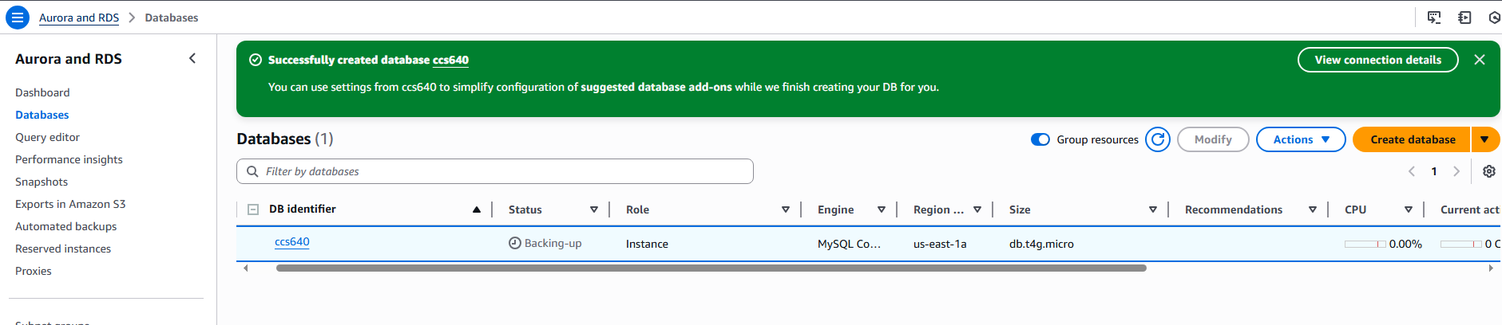
- Set up a target endpoint “ccs640target” for the MYSQL database with credentials CCS640admin and password.
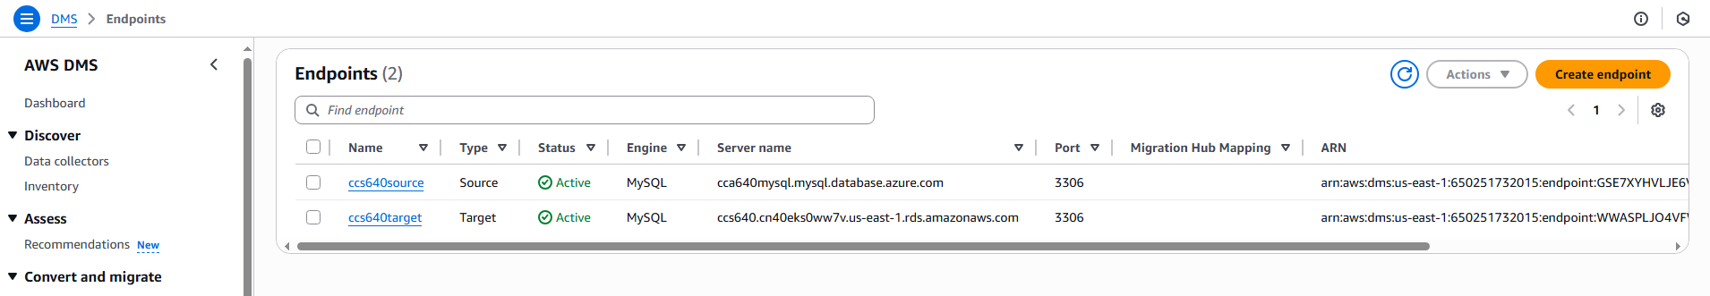
- Created a migration task “cca640migration”.
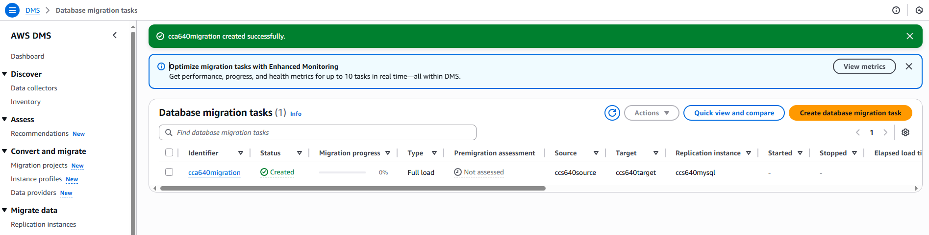
- Verified the task status as "Created" in the DMS dashboard.
- Monitored the RDS instance via the Monitoring tab, noting minimal resource usage.
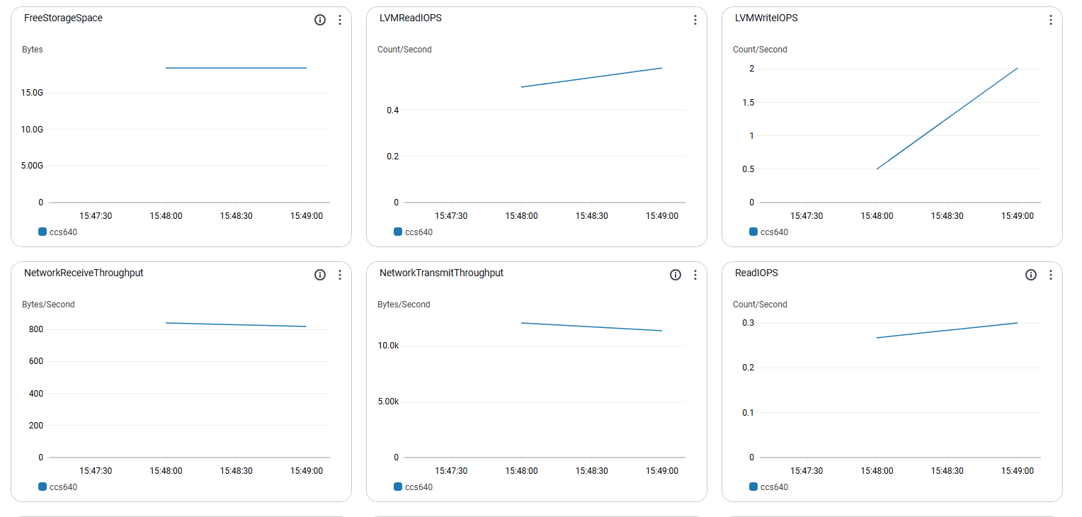
Private Cloud (Hyper-V) Migration to AWS
Lab Summary: In this lab I used the AWS Application Migration Service to transfer a BallotOnline Hyper-V server to AWS cloud infrastructure. In this process I needed to set up the migration service then test the EC2 instance. After the test launch was completed I verified the service was migrated by web and FTP requests. After the verification I cleaned up the resources.
Steps Taken:
- Logged into the AWS Console. Then navigated to the Application Migration Service dashboard.
- Verified the source server ALO-AWSLABS-39 appeared in the source.
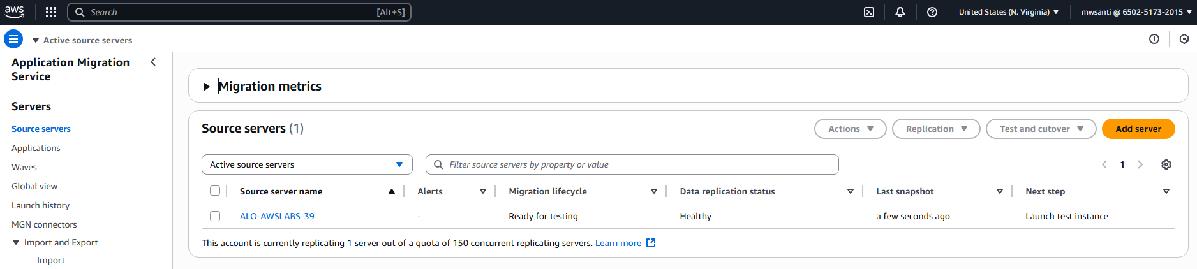
- Selected "Launch test instances" from the Replication dropdown.
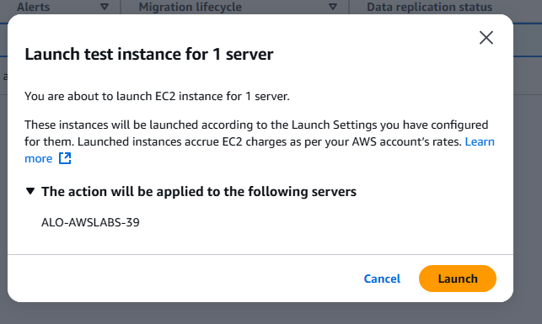
- Monitored the replication.
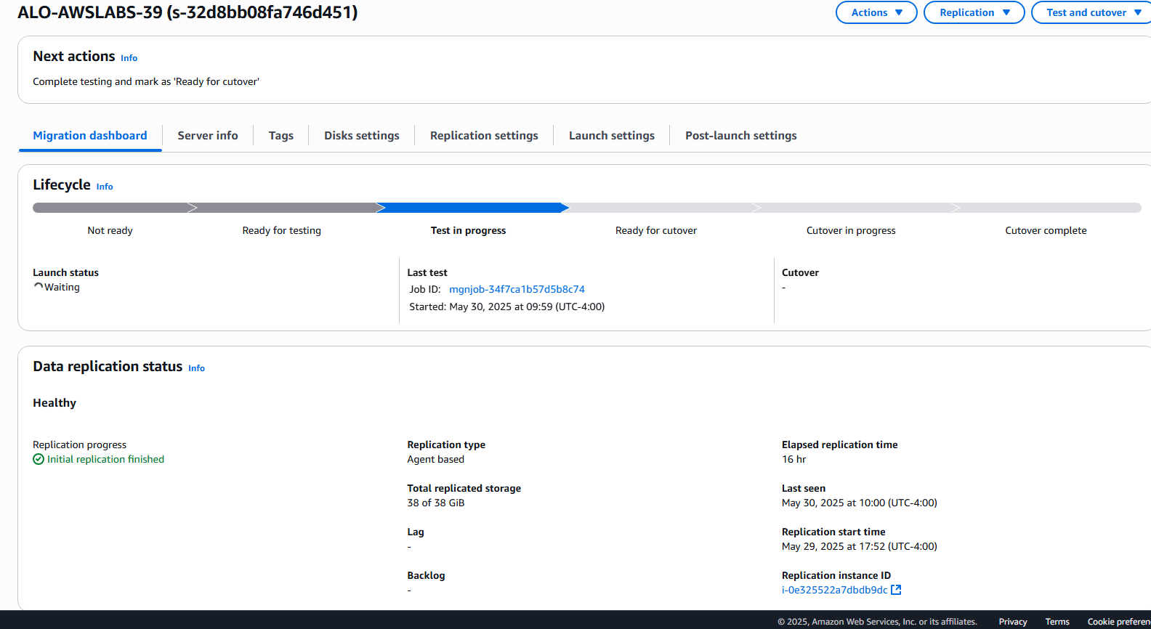
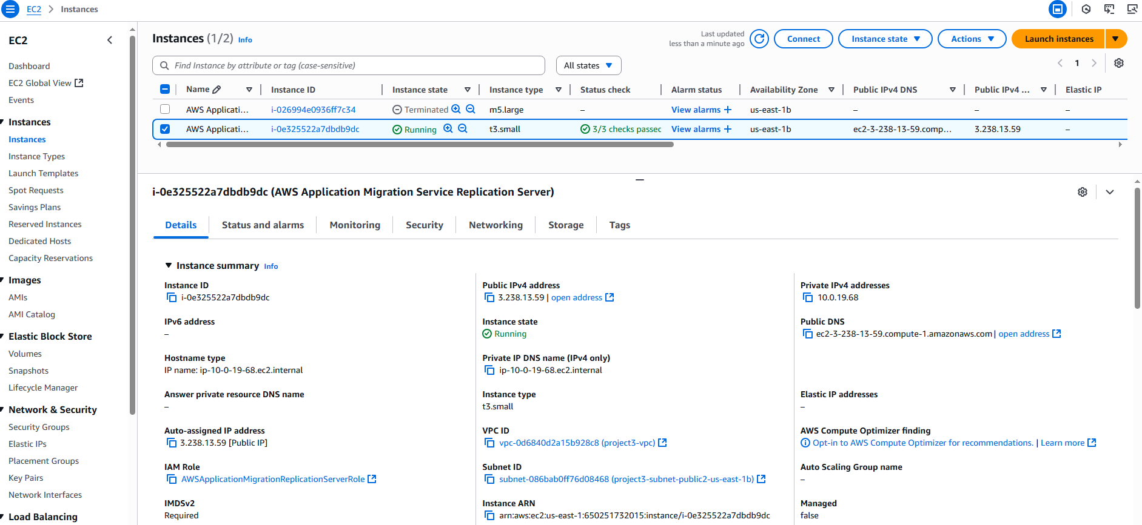
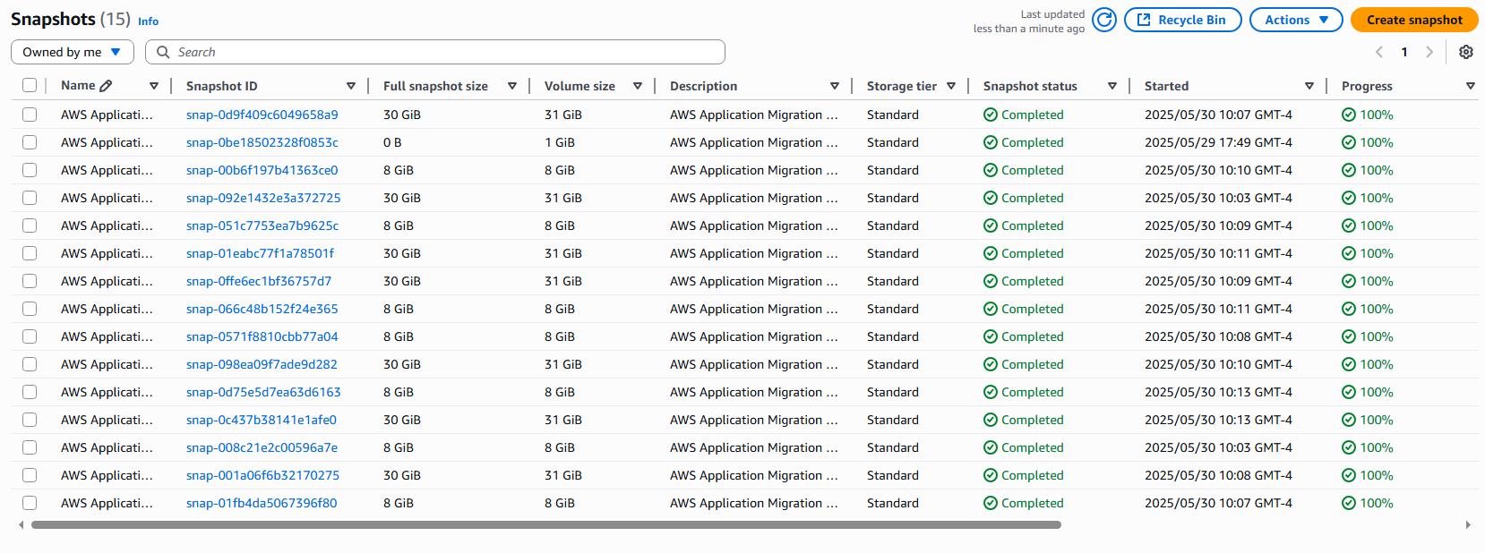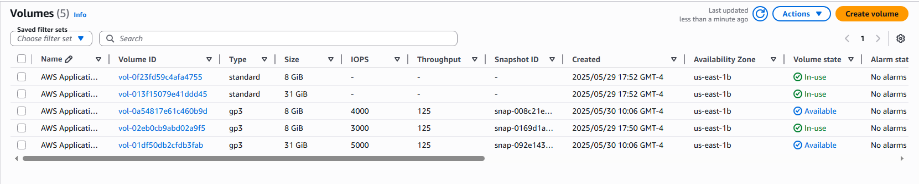
- Tested the web server by accessing the public IP address 3.238.13.59 in a browser to verify the BallotOnline intranet page.
- Tested the FTP server by accessing ftp://3.238.13.59
- Stopped/terminated instances and resources for cleanup.

Cloud Migration Recommendations
Our recommendation for BallotOnline is to fully migrate all on-premise servers into the cloud. In order to accomplish that we should use the lift and shift method as an initial migration strategy. This lift and shift should be used to move our applications into the cloud and not make any changes to them (Amazon Web Services, 2025). We will be able to reengineer the applications once the migration is over and employees are comfortable with cloud infrastructure. For the databases used by the applications we recommend using the Database Migration Service, because of its ease of use. As the Database Migration Service is running it will create the tables and keys on the cloud database server ensuring the data is transferred and cloud ready (Amazon Web Services, 2025). This automatic changes to the data into the cloud will enable the software developers to update the applications quickly as they know how they will operate on the cloud.
Conclusion
In conclusion, our migration of BallotOnline's infrastructure to Amazon Web Services is a exciting move in order to improve efficiency, scalability, and reduce cost. But we need to ensure that we prepare with goals, executive support, and use the correct tools in order to have a seamless migration. Also, picking the correct migration strategy of "lift and shift" or “create new” will guide the tools used and the speed of migration. But in general careful planning and execution will let us transition BallotOnline servers into the cloud and place BallotOnline on a path to have a robust and scalable network to support electronic voting world wide.

References
Amazon Web Service. (2025). What Is AWS Application Migration Service? From Amazon Web Service: https://docs.aws.amazon.com/pdfs/mgn/latest/ug/user-guide.pdf
Amazon Web Services. (2025). AWS Prescriptive Guidance. From Amazon Web Services: https://docs.aws.amazon.com/pdfs/prescriptive-guidance/latest/strategy-database-migration/strategy-database-migration.pdf
Amazon Web Services. (2025). AWS Server Migration Service in AWS GovCloud (US). From Amazon Web Services: https://docs.aws.amazon.com/govcloud-us/latest/UserGuide/govcloud-sms.html#:~:text=On%20March%2031%2C%202022%2C%20AWS%20discontinued%20AWS,the%20migration%20of%20on%2Dpremises%20servers%20to%20AWS.
Amazon Web Services. (2025). Getting started with AWS Database Migration Service. From Amazon Web Services: https://docs.aws.amazon.com/dms/latest/userguide/CHAP_GettingStarted.html
Amazon Web Services. (2025). What is AWS Database Migration Service? From Amazon Web Services: https://docs.aws.amazon.com/dms/latest/userguide/Welcome.html
Amazon Web Services. (2025). What Is AWS Migration Hub? From Amazon Web Services: https://docs.aws.amazon.com/migrationhub/latest/ug/whatishub.html
Amazon Web Services. (n.d.). Migrate and Modernize with AWS. From Amazon Web Services: https://aws.amazon.com/migrate-modernize-build/cloud-migration/
Microsoft. (2025, MAY 5). What is Azure Database Migration Service? From Learn: https://learn.microsoft.com/en-us/azure/dms/dms-overview
TechTarget. (2023, JUN). Maximizing Economic Advantages by Migrating to AWS Cloud Infrastructure. From Enterprise Strategy Group: https://d1.awsstatic.com/AWS%20Cloud%20Storage/ESG-Economic-Validation--Maximizing-Economic-Advantages-by-Migrating-to-AWS-Cloud-Infrastructure.pdf

